History of Halton County

Halton County, named for Major William Halton, secretary of the Lieutenant Governor, Francis Gore, is a compact little County. In shape it is oblong, twenty miles long by about fifteen miles wide and is watered by several large streams, the Credit and its branches, the Twelve Mile Creek and the Sixteen Mile Creek. It is bounded on the south by Lake Ontario, on the west by Peel County, north by Wellington and west by Wentworth. It originally formed part of the Home District set-up in the Provincial Act of 1792.
Subsequently, in 1816, along with Wentworth County, it formed the Gore District which comprised the following townships: Wentworth contained Ancaster, Barton, Binbrook, Brantford, Glanford, Unondago, Tuscarora and Saltfleet. Halton contained Beverley, Dumfries, Esquesing, Flamborough (later east and west), Nelson, Nassagaweya and Trafalgar.
In 1853, an Act of Parliament was passed to separate the two Counties. The first meeting to carry this Act into effect was held at Milton on July 12, 1853. By the end of 1854, Halton had its county buildings erected and separation had taken place. Wentworth retained eight townships and Halton was allowed four, Nelson, Trafalgar, Esquesing and Nassagaweya. At the time, this was considered to be very unfair, but Halton was out-voted and had to submit.
Nelson Township was named after Nelson, the hero of Trafalgar. 3450 acres were deeded to Chief Joseph Brant, Chief of the Indians of the Six Nations, for his services to the Crown. Many of the settlers were of United Empire Loyalist stock from the Niagara District. The Bates family was first to arrive around 1800. Mr. James Gage purchased three hundred and thirty-eight acres, part of the Brant Block, in 1810, and a village was laid out. This was called Wellington Square. In 1875, it changed its name to Burlington. Other well-known settlements in the area were Cummingsville, Hannahsville, Port Nelson, Dakota, Zimmerman, Lowville, Appleby, Kilbride and Tansley (originally called St. Anne).
Trafalgar Township was settled in 1806, when the Sovereigns, Proudfoots, Kaitings and Freemans arrived. Like Nelson, the land first surveyed along Dundas Street was quickly taken up and in 1818, a further block to the north was purchased from the Mississauga Indians. This was referred to as the New Survey. Several small communities sprang up which included Palermo, Postville (later Trafalgar), Sheridan, Proudfoot Hollow, Merton, Bronte Station, Glenorchy, Ash, Snider, Omaha, Auburn, Drumquin and the Boyne. Oakville was founded by Col. William Chisholm who purchased 968 acres in 1827. Col. Chisholm’s parents were Loyalists who settled in Nova Scotia and later purchased property at Burlington Bay, in Nelson Township. Milton, formerly known as Martin Mills, was settled by Jasper Martin and his family who had immigrated from New Castle, England and settled on Lot 14, Conc. 2, part of the New Survey, in 1821. Milton is the County Town of Halton.
Esquesing Township was opened in 1819, with a great influx of settlers from the British Isles and the Niagara District. Esquesing, an Indian name, means “that which lies at the end.” The first settlers are said to be James Hume and Ronald MacDonald. Norval was founded by James McNabb, and until 1840, was known as McNabsville. Limehouse was known as Fountain Green, the first settler being Adam Stull in 1820. Georgetown was founded by George Kennedy in 1823. Other well-known hamlets in Esquesing were the Scotch Block, Speyside, Mansewood, Glen Williams, Hornby, Peru, Ashgrove, Stewarttown, Ballinafad, Silvercreek, and Acton which was settled by the Adams brothers Ezra, Rufus and Zenas.
Nassagaweya Township means “a river with two outlets.” Although surveyed in 1819, it was somewhat slow in being opened up as it was less accessible to the markets than the land lying closer to the Lake. The first permanent settler is said to be William Trudgen, a native of Cornwall, England who settled on Lot 22, Concession 3, in 1822. Campbellville, the largest village in the township, was settled in 1832 by John Campbell, a native of Scotland. Kelso is now a deserted village three miles east of Campbellville. Haltonville and Moffatt were once rival communities and were nicknamed Sodom and Gomarrah. Haltonville is still Sodom on some maps. Other hamlets were Guelph Junction, Brookville, Knatchbull and Darbyville.
Halton County now comprises seven municipalities, Townships of Nelson and Nassagaweya and the towns of Milton, Oakville, Georgetown, Burlington and Halton Heights (formerly Acton).
In 1973, Halton County was dissolved to form the Regional Municipality of Halton.

Bibliography
“The Province of Ontario: A History 1615-1927” by Jesse Edgar
“Oakville and the Sixteen: The History of an Ontario Port”, 1953 by Hazel C. Mathews
“History of Nasagiweya”, 1889 by J. Norrish
“A History and Atlas of the County of Halton”, Halton District Women’s Institute

Compiled by Joan Hooks
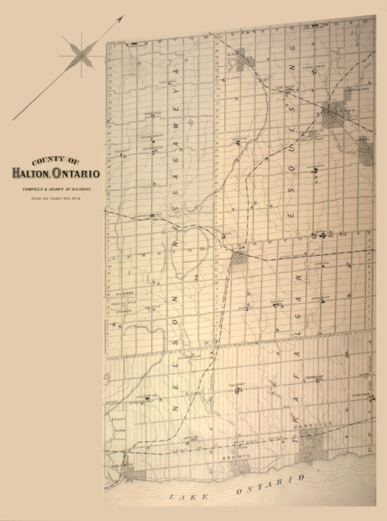
Copyright © McGill University, 2001

