A BRIEF HISTORY OF PEEL COUNTY

Peel County, known in the early days for its primeval forest of white oaks and towering pines, is thought to have received its name from Sir Robert Peel, an English parliamentarian.
For many years, few Indians of any kind lived in the area when the Mississauga’s began to occupy the flats along the Lower Credit River. Finally it became an Indian Village and later was named Port Credit.
For Loyalists coming from the United States and for discharged British soldiers, land was needed for their families who wished to settle in Upper Canada. Officials, acting for the British Crown, negotiated with the Mississauga chiefs who had claim of the land along the north shore of Lake Ontario stretching from Etobicoke to Burlington Bay. The treaty was signed in 1805, giving undisputed possession of all land, except for one mile each side of the Credit River from the mouth at Lake Ontario to the Lower Base Line, now Eglington Avenue.
In 1798 a Government Inn was already established at the mouth of the Credit which was leased by Thomas Ingersoll in 1805. Laura (Ingersoll) Secord was his daughter, who, in the Niagara area, was to become a heroine in the War of 1812 between Upper Canada and the Americans.
A military road, on the old inland Indian trail connecting York (Toronto) to Niagara, was authorized by John Graves Simcoe, Lieutenant Governor of Upper Canada.
The ink was barely dry on the Treaty of 1805, when John Wilcox set to work to survey the area of purchase, completed in 1806, known as the Old Survey. The Indians were pushed back as the white men settled and performed their settlement duties, in order to receive their Patents for new land in the Home District.
A demand for additional land, and a dispute between the Indians and the Upper Canada Government, led the Mississauga’s to surrender, in 1818, the lands which they had retained for their own use under the Treaty of 1805. In 1819, Timothy Street and Richard Bristol completed the New Survey of Toronto Township and all of Chinguacousy. By 1821 the rest of the County was completed.
The oldest village in Peel County was Streetsville, already well established by 1824. By 1837 tiny hamlets dotted the country and by 1850 Peel was developing a claim to fame because of its excellent wheat.
In 1856 Peel County voted to separate from York, but the separation did not come into effect until 1867. More than a century later in 1974, the County became the Region of Peel, comprising the Cities of Mississauga and Brampton and the Town of Caledon.

ALBION TOWNSHIP of the Home District, New Survey of 1819, was hilly and broken, in the northeast corner of the township, with a great deal of pine land. In the south, the land was better, and there were some good farms, according to the 1846 Canadian Gazetteer. The Humber River, with its many tributaries, provided sites for gristmills and saw mills. The population of Albion in 1821 was 110, with only 62 acres of land cultivated.
In 1824, George Bolton arrived and built a small gristmill, which had one run of stones and was a tremendous help to the settlers. This area of Bolton Village, formerly Bolton Mills, was incorporated in 1872, the only village of the township to do so. The English settlers had a fondness for horticulture. Bolton Village from 1840 kept growing and steadily increasing in business, being a commercial village of 500 acres. Although the village name is Bolton, the post office retained the name of Albion for some years.
Place names of Albion Township are: Columbia, Lockton, Glasgow, and Nunnville. Albion Township became part of the Town of Caledon in 1974.

CALEDON TOWNSHIP is famous for its caves, quarries, Rockside Pioneers and the Caledon Hills. It is situated on a ridge of the Niagara Escarpment, commanding an unsurpassed view and located in the southwestern portion of the township. A book by Berniece Trimble tells of the first settlers arriving in 1820, with dreams of making their fortunes in America.
Caledon Township is divided by Hurontario Street (Hwy #10) through its centre. It was the last township to be settled and is quite hilly, but the greater part is arable and well settled, with farming the major occupation. It was in 1850 that a township system was set up. According to the 1877 Peel County Atlas, the township was thickly dotted with thriving villages, namely, Alton, Charleston, Silver Creek, Mono Mills, Orangeville and Paisley.

CHINGUACOUSY TOWNSHIP, an Indian name pronounced Ching-coo-see, was open for settlement in 1819, in the New Survey and is the largest township in the county. The majority of the first settlers were from New Brunswick, and the children of United Empire Loyalists, but there were also many old country immigrants. By 1846 it was first class agricultural township with excellent rolling land and noted for its farm buildings. The Etobicoke river runs through east and centre of the township. In 1852 Brampton was incorporated as a village, and in 1865 was finally declared the County seat of Peel County.
Some place names of Chinguacousy Township are: Campbell’s Cross, Woodhill, Grahamsville, Cheltenham, Edmonton, Sandhill, Huttonville, Springbrook, Boston Mills, Tullamore, Mayfield, Victoria, Snelgrove, Salmonville, Brampton, etc.

TOWNSHIP OF THE GORE OF TORONTO first settled in 1819, on generally loam, and perhaps the richest in the county. The township derives its name from its peculiar shape between the townships of Chinguacousy, Toronto, Vaughan and Etobicoke. Flax was a major crop, along with wheat. By 1846 it was well settled by Irish and Scottish. Branches of the Humber River flowed through the Gore, with only a few early mills. Until 1831, the Gore operated jointly with Chinguacousy, but in that year, selected its own Municipal Council. There were no villages of any great size in 1877.
Some place names of the Gore are: Claireville, Woodhill, Castlemore, Tormore, Gribbin, Richview, etc. Toronto Gore Township is now part of the Cities of Mississauga and Brampton.

TORONTO TOWNSHIP’s prosperity began with wheat, five flour mills in the Streetsville area, another in Meadowvale. By the 1820’s to the 1830’s fruit orchards had established themselves in the Old Survey, the result of rapid settlement after the War of 1812. Churchville dates back to 1819 with the Amaziah Church grist and saw mills on the Credit river. Port Credit, Clarkson, Springfield (Erindale), Cooksville, Dixie, Burnhamthorpe, Derry West and Malton all shared in the development of the township, with the English, Irish, Scots, Germans and Americans. Streetsville was the principal village in the township.
In 1968, Toronto Township became the Town of Mississauga. With the advent of the Region of Peel in 1974, Mississauga became a City comprising the Towns of Mississauga, Streetsville and Port Credit, and its western border was extended into Trafalgar Township, Halton County.
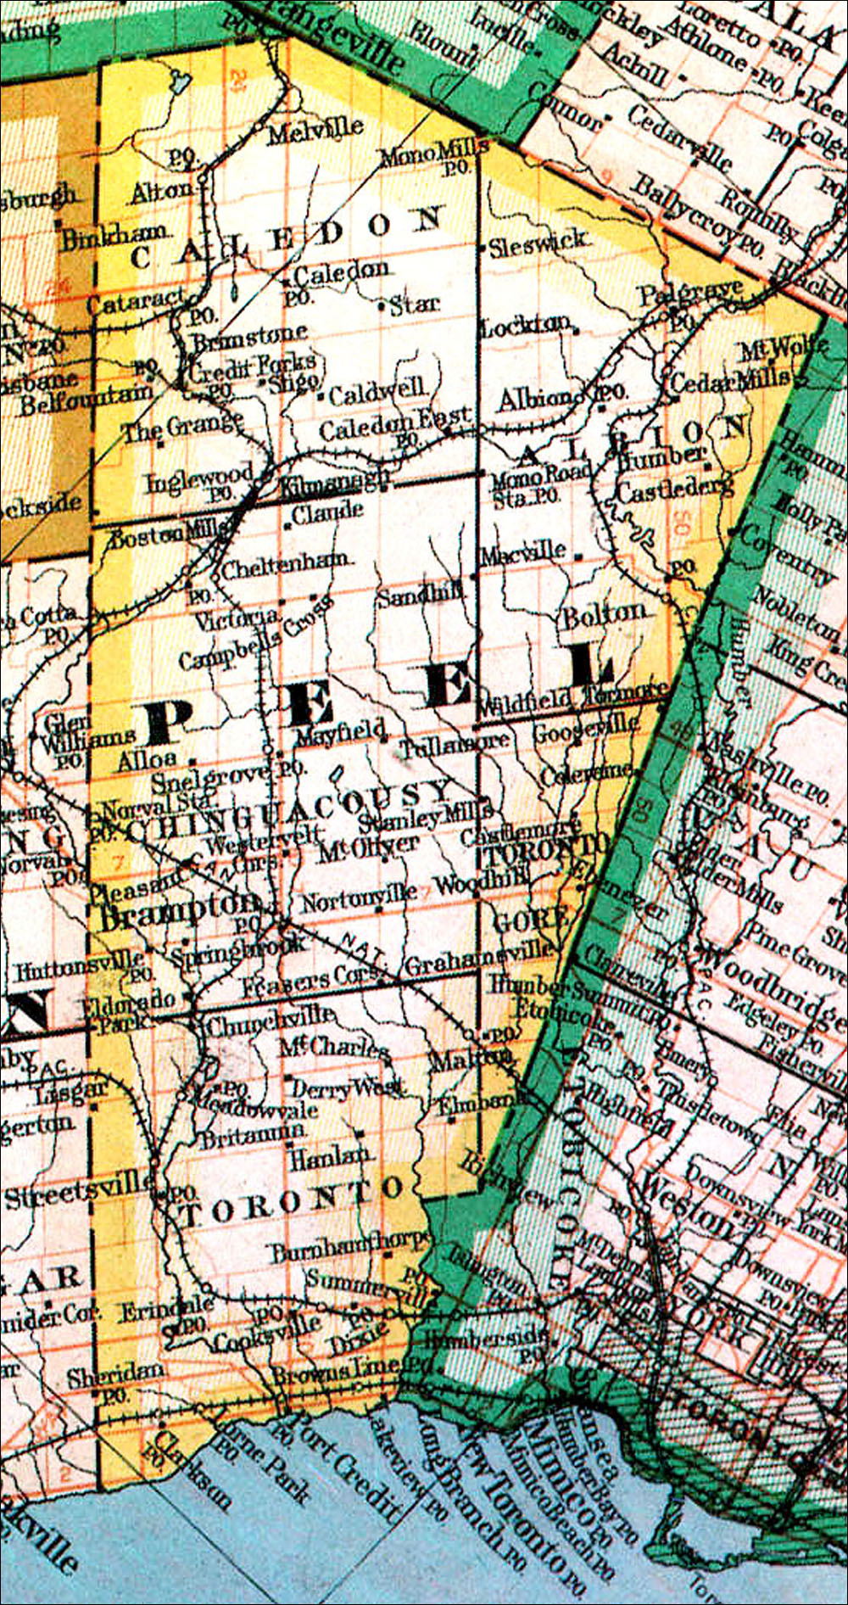
SOME BOOKS ABOUT PEEL COUNTY:
- The Story of Albion by Esther Heyes, 1961
- “Belfountain” Caves, Castles and Quarries in the Caledon Hills, Berniece Trimble, 1975
- Remember When…: A Collection of Pictures, a Collection of Memories:
a sequel to “Belfountain” Caves, Castles and Quarries by Berniece Trimble, 1976
- Terra Cotta by Mary Zatyko, 1979
- A History of Streetsville by Mary Manning, 1975

Books in the Credit Valley Series by The Boston Mills Press:
- Credit Valley Railway, “the Third Giant” by James Filby, 1974
- Cataract and the Forks of the Credit: A Pictorial History
by Ralph Beaumont, 1973
- Cook’s History of Inglewood by W. E. Cook, 1975
- Belfountain and the Tubtown Pioneers by Margaret Whiteside, 1975
- Cheltenham: A Credit Valley Mill Town by Frank Nelles, 1975
- Meadowvale & Churchville: A History by William E. Cook, 1975
- The Road to Boston Mills by James Filby, 1976
- At the Mouth of The Credit by Betty Clarkson, 1977
- The Rockside Pioneers by Robert Crichton, 1977
- Bolton by Susanne Baillie, Alanna May, Isabelle Schmelzer, 1989

